Sp2: Possessive Adjectives/Pronouns
Each person is using or needs HIS or HER own clothing items. Fill in blank with correct FORM of the logical word: mío, tuyo, suyo, nuestro. Remember that the ending matches what is describing. If "hers" refers to a libro (masculine), use suyo to match the book that it is descrsibing.
Paco lleva la gorra roja. Es .
Ana usa el lápiz de labios de color bonito. Es .
Necesito las botas porque va a nevar hoy. Las botas negras son .
Necesitas guantes hoy. Esos son .
Vamos a pintarnos como payaso (clown). Ese maquillaje es .

Sp2: Longer Possessive Adjectives Realidades2 2A
You are on the left and talking to a friend.
If something belongs to you, use a form of "mío".
If it belongs to your friend to whom you are talking, use a form of "tuyo" to say "your".
If it belongs to the other girl, use a form of "suyo" to say "her".
IF it belongs to the two men, use a form of "suyo" to say "their".
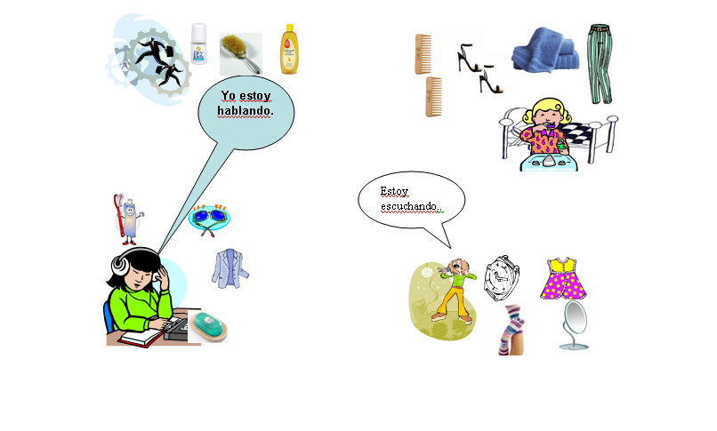
Es el cepillo .
Es la cama .
Son los calcetines .
Es el cepillo de dientes .
Es el espejo

